The Punchbowl Inn
Okewood hill
Christmas Menu
2 Courses £25.00 | 3 Courses £30.00
Starters
Roasted Peppers and Tomatoes Soup with Fresh Baked Bread
Goats Cheese Salad, Walnuts and Fig Dressing
Chicken Liver and Cognac Pate with Pickled Grapes and Toast
Duck Salad With Hoi Sin Dressing
Smoked Salmon with Capers, Brown Bread, Dill and Lemon Dressing

Mains
Roast Turkey with Cranberry & Chestnut Stuffing, Chipolata Pigs in Blankets, Roast Potatoes, Veggies, Yorkshire Pudding and Gravy
Cranberry And Goats Cheese Roast with Vegetables, Stuffing, Roast Potatoes & Yorkshire Pudding
Duck Leg Confit on Caramelised Red Onion Mash with Fine Beans and Orange Sauce
Pan Fried Salmon Fillet Served with New Potatoes, Wilted Spinach, Grilled Cherry Tomatoes & Tiger Prawn Sauce
Fettuccine Marinara and Vegetarian Parmesan
Green Vegetable Risotto, Spinach Asparagus & Peas with Vegetarian Parmesan

Desserts
Traditional Christmas Pudding Brandy Butter, Cream or Custard
Sticky Toffee Pudding with Vanilla Ice Cream
Apple Strudel with Ice Cream
Champagne and Raspberry Sorbet
Speciality Cheeseboard with Black Bomber Cheddar, Dirty Vicar and Norbury Blue Locally Made Cheese, Toasted breads, Biscuits, Celery and Grapes
***
Coffee And Mints
BOOKING FORM
Chosen Venue |  |  |  | Party Name
Contact Tel |  |  |  | Email
Number of Guests |  |  |  | Date |  |  | Time
STARTERS |  |  |  |  |  | Total:
Roasted Peppers and Tomatoes Soup
Goats Cheese Salad
Chicken Liver and Cognac Pate
Duck Salad
Smoked Salmon with Capers
MAINS
Roast Turkey
Cranberry And Goats Cheese Roast
Duck Leg Confit
Pan Fried Salmon Fillet
Fettuccine Marinara
Green Vegetable Risotto
DESSERTS
Traditional Christmas Pudding
Sticky Toffee Pudding
Apple Strudel
Champagne & Raspberry Sorbet
Speciality Cheeseboard
Please note that all bookings are subject to a 50% non-refundable deposit to secure your booking.
Pre-ordering is advised for all bookings over 6 people and will be subject to a 10% service charge.
All prices include VAT at the current rate.
We are now taking Christmas bookings for our sister pub, The White Hart, Cranleigh, with the Stables restaurant.
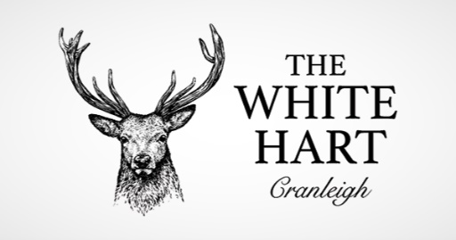  01483 275566  whitehartstables@gmail.com |  | 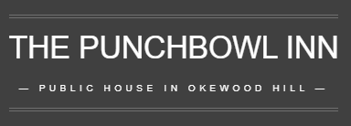  01306 6272049  punchbowlinnokewoodhill@gmail.com |  |  | 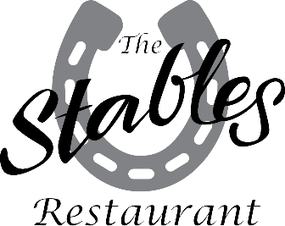  01483 275566  whitehartstables@gmail.com

