The Punchbowl inn
Okewood hill
Christmas Day Menu 2023

Starters
French Onion Soup, King Prawn Bisque or Roasted Pepper & Tomato Soup (V) with Fresh Baked Bread Roll Pan Fried Scallops with ’Nduja Butter and Cauliflower Puree
Tuna Carpaccio with Rocket, Capers and Chilli Herby Breaded Brie (V) with Salad & Cranberry Sauce

Mains
Traditional Roast Turkey or Rib of Beef with Stuffing, Pigs in Blankets, Honey Roast Parsnips, Roast Potatoes, Vegetables, Gravy & Yorkshire Pudding
Fillet of Salmon with a King Prawn Bisque with Dill Sauce, French Beans & New Potatoes Roasted Root Vegetables with Cranberry & Goats’ Cheese (V) with Stuffing, Roast Potatoes, Honey Roast
Parsnips, Vegetables, Gravy & Yorkshire Pudding

Desserts
Traditional Christmas Pudding (V) Brandy Butter, Cream or Custard Chocolate Fondant (V) with Ice Cream
Apple Strudel (V) with Madagascan Vanilla Ice Cream Champagne, Lemon or Raspberry (V) Sorbet
Speciality English Cheeseboard with Biscuits, Celery & Grapes
*** Coffee And Mints

£100.00 Per Person, £75.00 Per Child

BOOKING FORM
Chosen Venue |  |  | Party Name
Contact Tel |  |  | Email
Number of Guests |  |  | Date |  | Time
STARTERS |  |  |  | Total:
Soup (Onion/King Prawn/Tomato &
Pepper (Please indicate choice)
Pan Fried Scallops
Breaded Brie
Tuna Carpaccio
MAINS
Roast Turkey
Fillet of Salmon
Roasted Vegetables & Goats Cheese
Roast Beef
DESSERTS
Traditional Christmas Pudding
Chocolate Fondant
Apple Strudel
Champagne, Lemon or Raspberry
Sorbet (Please indicate choice)
Speciality English Cheeseboard

Please note that all bookings are subject to a 50% non-refundable deposit to secure your booking.
Pre-ordering is advised for all bookings over 6 people and all bills will be subject to a 10% service charge.
All prices include VAT at the current rate.

We are now taking Christmas bookings for our sister pub, The White Hart, Cranleigh, with the Stables restaurant.

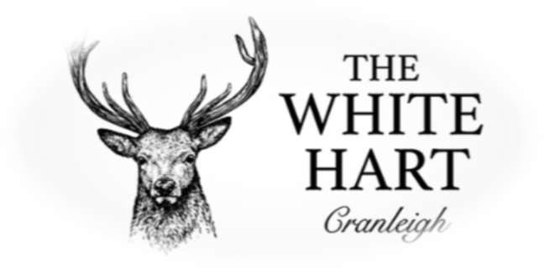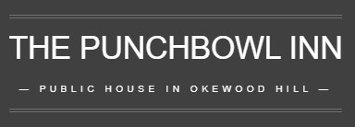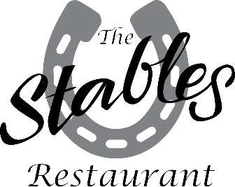

01483 275566
whitehartstables@gmail.com
01306 6272049
punchbowlinnokewoodhill@gmail.com
01483 275566
whitehartstables@gmail.com

