The Punchbowl inn
Okewood hill
Christmas Day Menu 2022
Starters
Roasted Peppers and Tomatoes Soup with Fresh Baked Bread
Pan Fried Scallops with Chorizo, Black Pudding & Pea Puree
Goats Cheese Fig and Onion Tart
Venison Carpaccio with Sour Cherry
Grilled King Prawns in a Pesto Sauce

Mains
Traditional Roast Turkey with Chestnut & Onion Stuffing, Chipolata Pigs in Blankets, Honey Roast Parsnips, Potatoes & Turkey Jus
Fillet of Salmon with a King Prawn Bisque Asparagus & New Potatoes
Roasted Vegetable and Chestnut Tart with Roast Potatoes, Parsnips & Vegetables
Honey & Mustard Glazed Fillet of Pork with Vegetables and Plum Sauce

Desserts
Traditional Christmas Pudding Brandy Butter, Cream or Custard
Chocolate Delice with Ice Cream
Apple Strudel with Madagascan Vanilla Ice Cream
Champagne and Raspberry Sorbet
Speciality Cheeseboard with Black Bomber Cheddar, Dirty Vicar and Norbury Blue Locally Made Cheese, Toasted breads, Biscuits, Celery and Grapes
***
Coffee And Mint

£95 Per Person

BOOKING FORM
Chosen Venue |  |  |  | Party Name
Contact Tel |  |  |  | Email
Number of Guests |  |  |  | Date |  |  | Time
STARTERS |  |  |  |  |  | Total:
Roasted Peppers and Tomatoes Soup
Pan Fried Scallops
Goats Cheese Tart
Venison Carpaccio
Grilled King Prawns
MAINS
Roast Turkey
Fillet of Salmon
Roasted Vegetable and Chestnut Tart
Honey & Mustard Glazed Fillet of Pork
DESSERTS
Traditional Christmas Pudding
Chocolate Delice
Apple Strudel
Champagne & Raspberry Sorbet
Speciality Cheeseboard
Please note that all bookings are subject to a 50% non-refundable deposit to secure your booking.
Pre-ordering is advised for all bookings over 6 people and will be subject to a 10& service charge.
All prices include VAT at the current rate.
We are now taking Christmas bookings for our sister pub, The White Hart, Cranleigh, with the Stables restaurant.
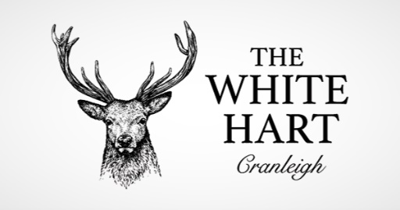  01483 275566  whitehartstables@gmail.com |  | 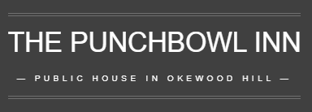  01306 6272049  punchbowlinnokewoodhill@gmail.com |  |  | 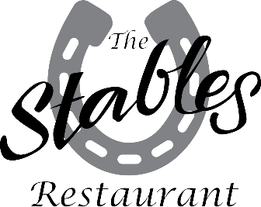  01483 275566  whitehartstables@gmail.com

